
Name of the Experiement : Token Launch – Deploying a Token Locally
Coding Phase : Pseudo Code/Flow Chart/Algorithm
- Open Remix IDE.
- Import the ERC20 contract from OpenZeppelin.
- Create a constructor that sets the token name, symbol, and mints initial supply.
- Compile the contract with Solidity ^0.8.20.
- Deploy to local blockchain using account 1.
- Use functions name(), symbol(), and totalSupply() to verify token.

Apparatus/Software Used:
- OS: Windows or others.
- Remix IDE.
- Wallet: MetaMask.
- Library: OpenZeppelin ERC20

Testing Phase:

- Call name() → returns "SwadToken"
- Call symbol() → returns "SWA"
- Call totalSupply() → returns 100000000
- Call balanceOf(owner) → shows total supply in deployer’s account.

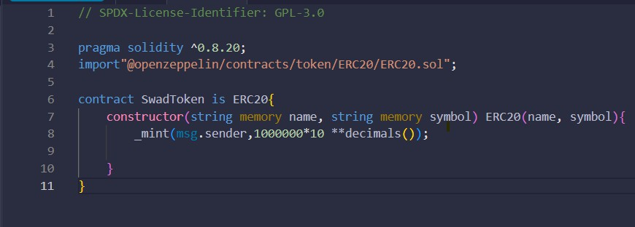
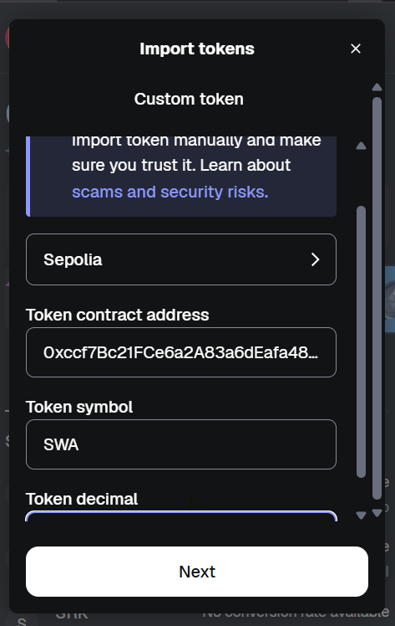
Implementation Phase: Final Output (no error)

Step 1: Open Remix IDE.

- Open Browser/Brave.
- Search Remix IDE. Step 2: Write Smart Contract.
- Create a new file in inside of contract using .sol.
- Write code:

Step 3: Code Compile and Deploy .

- Click the Solidity compiler and compile this file.
- Click Deploy & run transaction Option .
- Depioy the write of some string name and symbol.

Step 4: Add Token to MetaMask.

- In MetaMask, click "Import Tokens".
- Enter your deployed contract address.
- Your token should appear in the wallet.

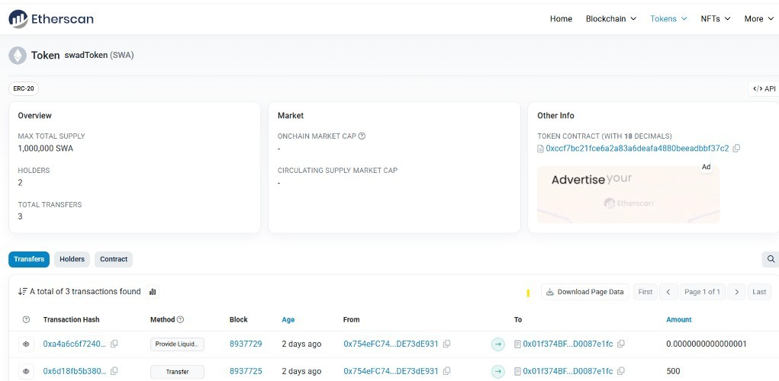
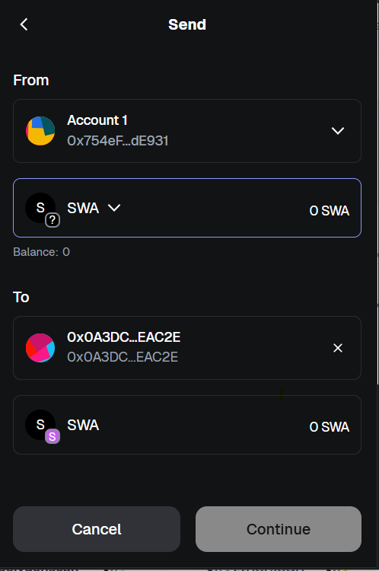
Step 5:Check Token Details.

- name() → should return "SwadToken"
- symbol() → should return "SWA"
- totalSupply() → should return 10000000.

Step 6: Transfer Token:

- Use transfer(receiver_address, amount) to send tokens to another account.
- Then check balanceOf(receiver_address) to confirm transfer.

Observations

- The OpenZeppelin library makes ERC20 token creation quick and secure.
- Local deployment requires no real ETH.
- Token functions behave exactly the same as on testnet/mainnet.

